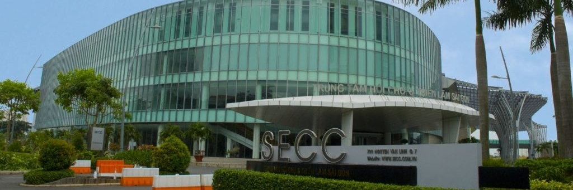
1.
Location: Saigon Exhibition and Convention Center (SECC), District 7 Price: $35 / ticket
Event Detail
- Name: TechFest 2026: Artificial Intelligence Breakthroughs
- Category: Tech Conference
- Format: Offline
- Registration Deadline: Jul 15, 2026, 11:59 PM
- Ticket Price: $35 per ticket
- Seats Left: 120/300
- Registered Attendees: 180 people
- Start Time: Jul 20, 2026, 8:00 AM
- Description: A premier gathering for tech enthusiasts, developers, and researchers to explore the latest advancements in GenAI, Machine Learning, and neural networks.
- Speaker Lineup: Dr. Hoang Nguyen - Head of AI Research, TechCore Sarah Jenkins - Lead Data Scientist, GlobalAI Solutions
- Ticket Types: Standard Pass: Full access to keynotes and exhibition area ($35) VIP Pass: Includes exclusive networking lunch and speaker meet-and-greet ($89)
- Refund Policy: Full refund available until 7 days prior to the event.
- Check-in: Present your QR code at the main registration desk at least 30 minutes before the opening keynote.
- Contact: thienphu210505@gmail.com - 0365349036

2.
Location: Innovation Lab, 23 Nguyen Dinh Chieu Street, District 3 Price: $15 / ticket
Event Detail
- Name: CyberSecurity Hackathon: Securing the Digital Foundation
- Category: Programming Competition
- Format: Offline
- Registration Deadline: Aug 01, 2026, 5:00 PM
- Ticket Price: $15 per ticket
- Seats Left: 15/50
- Registered Attendees: 35 people
- Start Time: Aug 10, 2026, 7:00 AM
- Description: An intensive 48-hour coding marathon where teams will build innovative security solutions to protect enterprise digital assets against modern cyber threats.
- Speaker Lineup: Tuan Le - Chief Security Officer, SecureNet Emily Tran - Cloud Security Architect, CyberFort
- Ticket Types: Competitor Pass: Registration fee for one team member including meals ($15) Observer Pass: Access to final pitch day and closing ceremony ($5)
- Refund Policy: Non-refundable after registration deadline.
- Check-in: Bring a valid ID and laptop. Check-in opens strictly at 6:30 AM.
- Contact: thienphu210505@gmail.com – 0365349036


3.
Location: The Hive, 94 Xuan Thuy, Thao Dien, District 2 Price: $25 / ticket
Event Detail
- Name: DevOps Day: Enterprise System Optimization
- Category: Specialized Workshop
- Format: Offline
- Registration Deadline: Sep 05, 2026, 12:00 PM
- Ticket Price: $25 per ticket
- Seats Left: 40/100
- Registered Attendees: 60 people
- Start Time: Sep 12, 2026, 9:00 AM
- Description: Deep-dive sessions into CI/CD pipelines, containerization, and infrastructure as code to help engineering teams streamline their deployment processes.
- Speaker Lineup: David Smith - Senior DevOps Engineer, CloudScale Mai Pham - Site Reliability Expert, TechOps VN
- Ticket Types: Standard Admission: Workshop access and digital materials ($25) Premium Admission: Includes a 1-on-1 infrastructure consultation ($65)
- Refund Policy: 50% refund if canceled 3 days before the event.
- Check-in: Display your booking confirmation email upon entry.
- Contact: thienphu210505@gmail.com – 0365349036

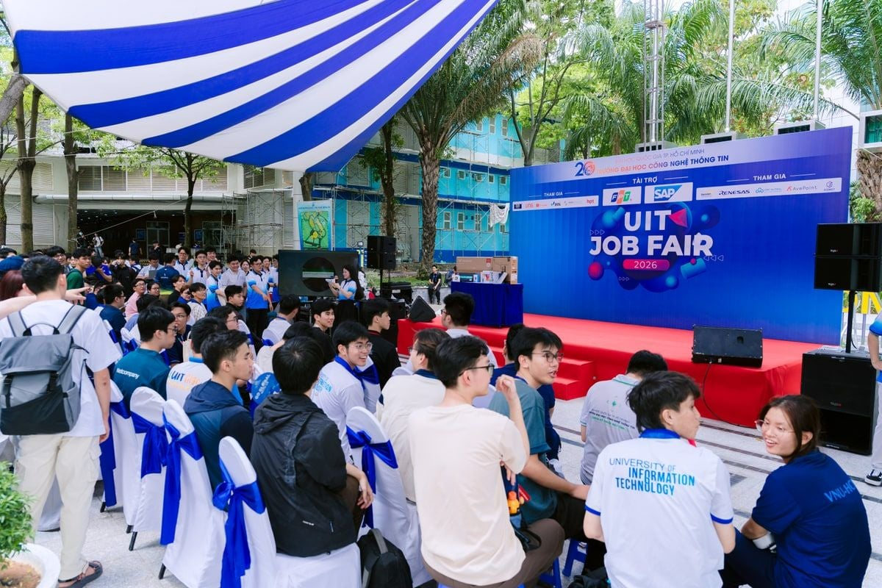

4.
Location: Main Campus Courtyard, Linh Trung Ward, Thu Duc City Price: $0 / ticket
Event Detail
- Name: UIT Career Fair: Employer Connection 2026
- Category: Job Fair
- Format: Offline
- Registration Deadline: Oct 15, 2026, 11:59 PM
- Ticket Price: $0 per ticket
- Seats Left: 450/1000
- Registered Attendees: 550 people
- Start Time: Oct 20, 2026, 8:00 AM
- Description: Connect directly with top tech companies, submit your CV, and participate in on-the-spot interviews for internship and fresher roles.
- Speaker Lineup: HR Representatives from VNG, FPT Software, and Shopee
- Ticket Types: Student Pass: Free entry for all university students ($0) Alumni Pass: Fast-track entry for graduated students ($0)
- Refund Policy: Not applicable (Free event).
- Check-in: Present your student ID card or alumni email confirmation at the gate.
- Contact: thienphu210505@gmail.com - 0365349036

5.
Location: Liberty Central Hotel, 17 Ton Duc Thang, District 1 Price: $10 / ticket
Event Detail
- Name: Workshop: Conquering Global Study Abroad Scholarships
- Category: Skill Development Seminar
- Format: Offline
- Registration Deadline: Nov 02, 2026, 10:00 AM
- Ticket Price: $10 per ticket
- Seats Left: 25/80
- Registered Attendees: 55 people
- Start Time: Nov 05, 2026, 2:00 PM
- Description: Learn the secrets to crafting a winning statement of purpose, securing strong recommendation letters, and acing scholarship interviews from successful alumni.
- Speaker Lineup: Prof. Anh Vu - Academic Advisor, Global Edu Linh Hoang - Chevening Scholarship Alumnus
- Ticket Types: General Entry: Seminar access and Q&A session ($10) Mentorship Bundle: Includes a personal essay review session ($40)
- Refund Policy: Full refund if requested 24 hours prior to the event.
- Check-in: Show your e-ticket at the conference room entrance.
- Contact: thienphu210505@gmail.com – 0365349036


6.
Location: Hall A, National University Ho Chi Minh City, Thu Duc City Price: $20 / ticket
Event Detail
- Name: Youth Science Conference: Computer Vision Applications
- Category: Academic Conference
- Format: Offline
- Registration Deadline: Nov 20, 2026, 6:00 PM
- Ticket Price: $20 per ticket
- Seats Left: 60/150
- Registered Attendees: 90 people
- Start Time: Nov 25, 2026, 8:30 AM
- Description: A platform for young researchers to present their latest findings in object detection, semantic segmentation, and AI-driven image processing.
- Speaker Lineup: Dr. Binh Tran - Computer Vision Researcher Hung Le - AI Research Assistant
- Ticket Types: Attendee Pass: Access to all paper presentations ($20) Author Pass: Required for paper presenters, includes publication fee ($50)
- Refund Policy: No refunds for Author Passes. Attendee Passes refundable up to 48 hours before.
- Check-in: Pick up your badge at the registration desk using your confirmation code.
- Contact: thienphu210505@gmail.com - 0365349036



7.
Location: Acoustic Bar, 6E1 Ngo Thoi Nhiem, District 3 Price: $18 / ticket
Event Detail
- Name: Summer Melodies: Viet Indie Music Night
- Category: Live Concert
- Format: Offline
- Registration Deadline: Dec 01, 2026, 12:00 PM
- Ticket Price: $18 per ticket
- Seats Left: 30/200
- Registered Attendees: 170 people
- Start Time: Dec 01, 2026, 8:00 PM
- Description: A cozy music night featuring the best underground and indie artists in the city, performing acoustic sets and original summer tracks.
- Speaker Lineup: Chillies (Guest Band) Vu (Headline Artist)
- Ticket Types: Standing Ticket: Floor access ($18) VIP Seating: Reserved table with a complimentary drink ($35)
- Refund Policy: All sales are final. Tickets are transferable.
- Check-in: Doors open at 7:30 PM. Have your digital ticket ready to scan.
- Contact: thienphu210505@gmail.com - 0365349036


8.
Location: The Factory Contemporary Arts Centre, Thao Dien, District 2 Price: $12 / ticket
Event Detail
- Name: Art Exhibition: Colors of the Modern Metropolis
- Category: Art & Culture
- Format: Offline
- Registration Deadline: Dec 10, 2026, 5:00 PM
- Ticket Price: $12 per ticket
- Seats Left: 80/250
- Registered Attendees: 170 people
- Start Time: Dec 15, 2026, 10:00 AM
- Description: An immersive visual art experience showcasing paintings and digital artwork that reflect the chaos, beauty, and rapid growth of modern urban life.
- Speaker Lineup: Khoa Pham - Contemporary Artist Ly Nguyen - Art Curator
- Ticket Types: Single Entry: One-time access to the gallery ($12) Guided Tour Pass: Includes an audio guide and weekend curator walkthrough ($25)
- Refund Policy: Tickets are valid for any day within the exhibition week; non-refundable.
- Check-in: Walk-ins allowed. Present ticket at the front gate for wristband exchange.
- Contact: thienphu210505@gmail.com – 0365349036
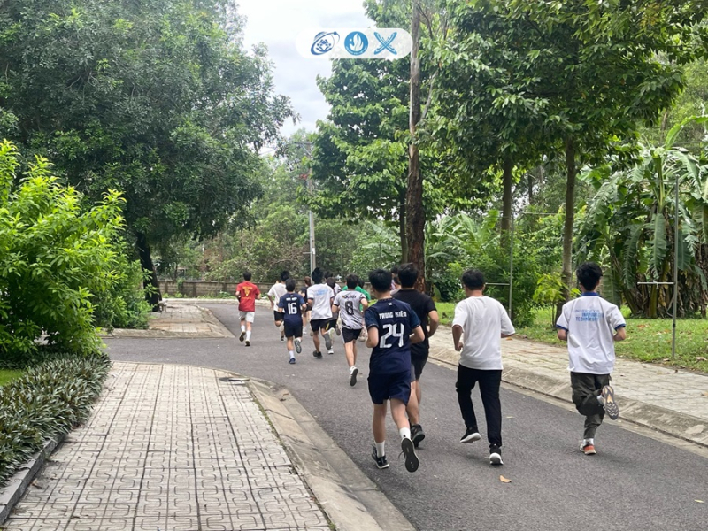

9.
Location: Sala Park, Thu Thiem New Urban Area, District 2 Price: $25 / ticket
Event Detail
- Name: UIT Marathon: Running for Community Health
- Category: Sports Event
- Format: Offline
- Registration Deadline: Dec 20, 2026, 11:59 PM
- Ticket Price: $25 per ticket
- Seats Left: 150/1000
- Registered Attendees: 850 people
- Start Time: Dec 28, 2026, 5:00 AM
- Description: A charity run to promote physical wellness and raise funds for local hospitals. Open to all students, professionals, and running enthusiasts.
- Speaker Lineup: Coach Tuan Anh - Marathon Specialist (Warm-up Session)
- Ticket Types: 5KM Runner: Includes race bib and finisher medal ($25) 10KM Runner: Includes race bib, event T-shirt, and finisher medal ($35)
- Refund Policy: No refunds. Participant kits will be mailed if unable to attend.
- Check-in: Race kits must be collected two days prior to the event at the designated booth.
- Contact: thienphu210505@gmail.com - 0365349036
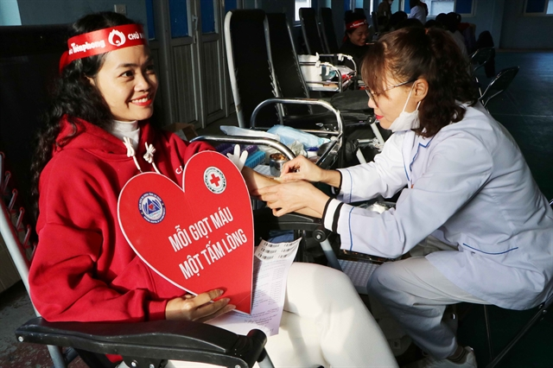
10.
Location: Student Cultural House, National University Village, Thu Duc City Price: $0 / ticket
Event Detail
- Name: Volunteer Blood Donation Day: Sharing Drops of Red
- Category: Charity & Community
- Format: Offline
- Registration Deadline: Jan 05, 2027, 8:00 AM
- Ticket Price: $0 per ticket
- Seats Left: 20/300
- Registered Attendees: 280 people
- Start Time: Jan 08, 2027, 7:30 AM
- Description: Join hands to save lives in our bi-annual blood drive. Donors will receive a health check, certificate, and post-donation snacks.
- Speaker Lineup: Dr. Minh Chau - Hematology Department, Cho Ray Hospital
- Ticket Types: Blood Donor Registration: Reserve a time slot to donate ($0) Volunteer Assistant: Register to help manage the event logistics ($0)
- Refund Policy: Not applicable.
- Check-in: Please bring a valid ID/CCCD. Ensure you have eaten breakfast and rested well before checking in.
- Contact: thienphu210505@gmail.com - 0365349036

